SQL DEVELOPER INTERNSHIP
WEEK 4 REPORT
Dynamic Reporting and Data Visualization Using SQL
  - Virtual Retail Environment | PostgreSQL reporting design
Prepared by: Vipul Janardan Patil
Database target: PostgreSQL 15+
Validation engine: SQLite mirror (query logic validation)

Executive Summary
This report develops a reproducible reporting layer for the virtual retail database established in the earlier internship weeks. Week 1 supplied the normalized retail entities and relationships; Week 2 documented the ETL lifecycle and data-quality controls; Week 3 focused on query performance and evidence-based optimization. Week 4 uses those foundations to answer management questions about product sales, category performance, customer value, repeat purchasing, monthly trends, inventory risk and order status.
The reporting dataset is synthetic and deterministic (seed 20261105). It contains 300 customers, 40 products, 2,400 orders and 4,730 order-item rows, across 3 warehouses. All reporting outputs were generated by executing the query logic against a local SQLite verification mirror. PostgreSQL-specific SQL scripts are supplied for the internship database. No PostgreSQL runtime was available during artifact generation, so the report does not claim PostgreSQL execution or measured performance results.
The report emphasizes metric definitions and decision quality. Sales revenue is calculated from order-item quantity multiplied by the price captured on the order line. Delivered revenue includes only orders whose status is delivered; it is not labelled net revenue because the model does not include a complete returns/refunds ledger, taxes, discounts or chargebacks. Inventory turnover is not claimed because the current schema stores balances rather than dated stock movements or cost of goods sold. A stock-cover estimate is provided as a transparent operational proxy.

1. Objectives and Scope
- Convert retail business questions into repeatable SQL reports.
- Use joins, CTEs, aggregations, conditional logic, subqueries and window functions.
- Provide executed result samples, full CSV exports and validation evidence.
- Recommend charts that match the analytical question and explain how to interpret them.
- Document business definitions, assumptions, limitations, optimization rationale and future improvements.

2. Continuity with Weeks 1–3
Week | Foundation | How Week 4 reuses it
Week 1 – Data modeling | Normalized entities, primary/foreign keys, product/order/inventory relationships. | Reports join customers, categories, products, orders, order_items and inventory without duplicating facts.
Week 2 – ETL planning | Extract, stage, transform, validate and load; data-quality checks. | The report assumes validated, consistently typed data and recommends a refresh pipeline with quality gates.
Week 3 – SQL optimization | EXPLAIN plans, composite/partial indexes, sargable date filters, trade-off analysis. | Reporting queries use selective predicates, explicit columns, pre-aggregation and indexes aligned to common filters.

3. Dataset, Schema and Reproducibility
The PostgreSQL target schema is retail, consistent with the Week 3 report. The original Week 1 package defines customers, categories, products, suppliers, product_suppliers, warehouses, inventory, orders, order_items, payments and shipments. Week 4 queries use the relevant subset. The supplied data generator creates a separate deterministic synthetic reporting dataset with the same core relationships. It is designed for repeatability and demonstration, not to replace production records.
Table | Rows generated
customers | 300
categories | 5
products | 40
suppliers | 8
product_suppliers | 40
warehouses | 3
inventory | 120
orders | 2,400
order_items | 4,730
payments | 2,400
shipments | 1,906
Data range: synthetic order timestamps span January 2025 through October 2026. Inventory snapshot timestamp: 1 November 2026. Currency is treated as generic synthetic currency units because the inherited schema does not declare an ISO currency column. For a real multi-currency retailer, currency must be stored and reports must avoid summing unlike currencies.

3.1 Business definitions and assumptions
- Delivered revenue = SUM(order_items.quantity × order_items.unit_price) for orders with order_status = delivered. This is fulfilled merchandise value, not accounting net revenue.
- Units sold = sum of order-item quantities for delivered orders only. Cancelled, refunded, pending and in-flight orders are excluded from fulfilled sales.
- Average order value (AOV) = delivered merchandise value divided by delivered order count. It is not the average line value.
- Repeat customer = customer with at least two delivered orders in the full reporting period. This is a simple repeat-purchase measure, not a cohort retention rate.
- Low stock = quantity_on_hand <= reorder_level at a given warehouse. This is a threshold rule, not a forecast.
- Stock cover days = current on-hand units divided by average daily delivered units over the trailing 90-day window. It is a proxy and can be unstable for intermittent demand.
- Inventory turnover is not calculated: no dated inventory movement ledger or cost-of-goods-sold field exists in the inherited model.

4. Reporting Architecture and Workflow
Source tables → ETL validation → reporting SQL/CTEs → result tables or views → dashboard charts → management action. Each report should have a refresh timestamp, reporting period, metric definition and data-quality status. For repeated dashboard use, stable SQL views or materialized views can provide a governed interface between transactional tables and visualization tools.

5. SQL Reporting Analyses

01_top_products. Top products by delivered revenue
Business question: Which products contribute the most fulfilled merchandise revenue?
Query logic: Joins order headers to line items, products and categories; aggregates units, distinct orders and line revenue per product; uses a window sum for revenue share and RANK for ordering.
Result evidence: The exact CSV/Markdown output is included in outputs/. The displayed figures below are generated from the deterministic synthetic dataset and were executed against the SQLite verification mirror.
product_id | sku | product_name | category_name | units_sold | delivered_revenue
24 | SKU-0024 | Home & Kitchen Product 24 | Home & Kitchen | 181 | 4543261.09
4 | SKU-0004 | Home & Kitchen Product 04 | Home & Kitchen | 174 | 4371861.36
18 | SKU-0018 | Accessories Product 18 | Accessories | 167 | 4190504.2800000003
38 | SKU-0038 | Accessories Product 38 | Accessories | 167 | 4183366.6999999997
21 | SKU-0021 | Electronics Product 21 | Electronics | 159 | 3978893.91
Interpretation: A high-revenue product may lead because of price, volume or both. Compare units sold with revenue share before deciding whether to prioritize availability, pricing or promotion.
Visualization: Sorted horizontal bar chart of delivered revenue; optionally show units as labels or a second aligned chart.
Limitations and trade-offs: Revenue does not equal profit. Supply cost, discounts, returns and marketing spend are not included.
Recommended action: Protect availability of high-contribution products; assess margin and stock cover before increasing promotion.

02_category_performance. Category revenue and mix
Business question: Which categories account for the largest share of delivered sales?
Query logic: Joins categories to products, order items and orders; aggregates revenue, units and distinct delivered orders; window sum calculates category revenue share.
Result evidence: The exact CSV/Markdown output is included in outputs/. The displayed figures below are generated from the deterministic synthetic dataset and were executed against the SQLite verification mirror.
category_name | delivered_orders | units_sold | revenue | revenue_share_pct
Home & Kitchen | 606 | 1330 | 16802000.19 | 35.87
Accessories | 593 | 1223 | 13289269.87 | 28.37
Electronics | 602 | 1315 | 7250244.75 | 15.48
Home Office | 572 | 1266 | 5810434.76 | 12.4
Fitness | 582 | 1276 | 3689670.27 | 7.88
Interpretation: A category with high revenue share may be strategically important, but revenue concentration can also create dependency risk. Compare order count and units to understand whether the category has broad demand.
Visualization: Column chart for category revenue plus a 100% stacked bar or donut for share. Use the bar chart as the primary comparison.
Limitations and trade-offs: Categories with no delivered orders do not appear because the query uses inner joins. Add LEFT JOIN logic if zero-sales categories must be shown.
Recommended action: Review assortment depth and stock allocation in leading categories; investigate low-share categories before discontinuing products.

03_monthly_trend. Monthly delivered sales trend
Business question: How does fulfilled revenue change month by month?
Query logic: Groups delivered order lines by calendar month; LAG compares each month with the prior month; calculates absolute and percentage month-over-month change.
Result evidence: The exact CSV/Markdown output is included in outputs/. The displayed figures below are generated from the deterministic synthetic dataset and were executed against the SQLite verification mirror.
sales_month | delivered_orders | revenue | revenue_change | mom_growth_pct
2025-01 | 38 | 1269811.57 | None | None
2025-02 | 56 | 1206647.32 | -63164.25 | -4.97
2025-03 | 48 | 1320990.4 | 114343.08 | 9.48
2025-04 | 53 | 1552404.34 | 231413.94 | 17.52
2025-05 | 67 | 1677360.2 | 124955.86 | 8.05
Interpretation: Seasonality and promotions can influence monthly movement. The latest month is incomplete (October 2026 in this generated dataset), so it must not be compared directly with a complete month without a partial-period warning.
Visualization: Line chart with monthly revenue; annotate major promotions and mark incomplete periods. A companion line can show order count.
Limitations and trade-offs: Month-over-month growth is volatile on small bases. The report has no promotion calendar, traffic or margin data to explain causality.
Recommended action: Use year-over-year comparisons when a full prior-year period exists; compare equivalent day ranges and add promotion/event context.

04_customer_value. Highest-value delivered customers
Business question: Which customers contribute the most delivered merchandise revenue?
Query logic: Aggregates delivered orders and line revenue per customer; computes AOV; uses CASE for simple frequency segments and RANK for revenue position.
Result evidence: The exact CSV/Markdown output is included in outputs/. The displayed figures below are generated from the deterministic synthetic dataset and were executed against the SQLite verification mirror.
customer_id | full_name | delivered_orders | delivered_revenue | first_delivered_order | latest_delivered_order
12 | Customer 012 | 8 | 419365.85 | 2025-04-24 19:25:00 | 2026-10-09 08:56:00
248 | Customer 248 | 9 | 387673.29 | 2025-01-01 08:37:00 | 2026-10-17 15:27:00
94 | Customer 094 | 7 | 384984.59 | 2025-04-28 09:19:00 | 2026-08-20 14:41:00
115 | Customer 115 | 10 | 382151.0 | 2025-05-12 13:15:00 | 2026-10-30 12:21:00
227 | Customer 227 | 7 | 375559.2 | 2025-10-28 19:18:00 | 2026-10-17 10:13:00
Interpretation: Revenue ranking identifies valuable customers but does not establish profitability or lifetime value. A customer with fewer high-value orders may rank above a frequent low-value buyer.
Visualization: Ranked horizontal bar chart or Pareto curve showing cumulative revenue share by customer. Avoid a pie chart with many customer slices.
Limitations and trade-offs: Customer names are synthetic. No acquisition cost, margin, churn probability or marketing-contact permission is modeled.
Recommended action: Use customer-level insights for service prioritization and retention experiments, subject to privacy and consent controls.

05_repeat_customer_rate. Repeat purchase rate
Business question: What proportion of customers placed at least two delivered orders?
Query logic: Uses a customer-level subquery/CTE with LEFT JOIN so customers with zero delivered orders remain in the denominator; conditional aggregation counts repeat customers.
Result evidence: The exact CSV/Markdown output is included in outputs/. The displayed figures below are generated from the deterministic synthetic dataset and were executed against the SQLite verification mirror.
total_customers | repeat_customers | repeat_customer_pct | avg_delivered_orders_per_customer
300 | 293 | 97.67 | 5.68
Interpretation: The metric provides a simple repeat-purchase signal. It is sensitive to the observation window and customer tenure; new customers have had less time to make a second purchase.
Visualization: KPI card for repeat-customer percentage, paired with a cohort retention heatmap in a future version.
Limitations and trade-offs: This is not cohort retention, churn or customer lifetime value. The denominator includes all generated customers, including recently created customers.
Recommended action: Build acquisition-month cohorts and compare repeat purchase at 30/60/90 days to separate tenure effects.

06_low_stock. Low-stock items by warehouse
Business question: Which warehouse/product combinations are at or below their reorder threshold?
Query logic: Joins inventory to products and warehouses; filters quantity_on_hand <= reorder_level; computes the units required to return to threshold.
Result evidence: The exact CSV/Markdown output is included in outputs/. The displayed figures below are generated from the deterministic synthetic dataset and were executed against the SQLite verification mirror.
warehouse_name | sku | product_name | quantity_on_hand | reorder_level | units_below_reorder
Pune West | SKU-0025 | Fitness Product 25 | 8 | 24 | 16
Bengaluru South | SKU-0006 | Electronics Product 06 | 4 | 18 | 14
Pune West | SKU-0040 | Fitness Product 40 | 11 | 25 | 14
Bengaluru South | SKU-0030 | Fitness Product 30 | 7 | 19 | 12
Mumbai Central | SKU-0019 | Home & Kitchen Product 19 | 17 | 25 | 8
Interpretation: A low-stock flag identifies a replenishment exception. It does not guarantee an imminent stockout because lead time, reserved stock, supplier reliability and demand forecast are absent.
Visualization: Horizontal bar chart of on-hand units by product/warehouse with a reference marker for reorder level; use conditional table formatting for operations.
Limitations and trade-offs: A product can appear once per warehouse. Do not sum the same SKU across locations without deciding whether stock is transferable.
Recommended action: Prioritize items below threshold, then incorporate supplier lead time, open purchase orders and reserved quantities before creating purchase orders.

07_stock_cover_proxy. Estimated stock-cover days (proxy)
Business question: How many days of recent demand can current stock support?
Query logic: Aggregates delivered units in the trailing 90-day period by product; joins that demand to each warehouse balance; divides stock by average daily demand.
Result evidence: The exact CSV/Markdown output is included in outputs/. The displayed figures below are generated from the deterministic synthetic dataset and were executed against the SQLite verification mirror.
sku | product_name | warehouse_name | quantity_on_hand | units_sold_90d | avg_daily_units
SKU-0026 | Electronics Product 26 | Mumbai Central | 2 | 33 | 0.367
SKU-0006 | Electronics Product 06 | Bengaluru South | 4 | 41 | 0.456
SKU-0017 | Home Office Product 17 | Mumbai Central | 5 | 50 | 0.556
SKU-0035 | Fitness Product 35 | Mumbai Central | 4 | 36 | 0.4
SKU-0016 | Electronics Product 16 | Pune West | 5 | 42 | 0.467
Interpretation: Low cover days can signal replenishment urgency. A NULL cover value means no delivered units were observed in the window; it must not be interpreted as infinite safe stock.
Visualization: Dot plot or ranked horizontal bar chart with threshold bands (for example, 7/14/30 days) only after business owners approve policy thresholds.
Limitations and trade-offs: The proxy applies product-level demand to each warehouse and can overstate local demand if sales are not warehouse-attributed. It ignores stock reservations, seasonality and lead times.
Recommended action: Add warehouse-level sales attribution and stock movement history before using this as an automated replenishment trigger.

08_order_status. Order status distribution and value
Business question: How are orders distributed across operational statuses and what merchandise value is associated with each status?
Query logic: Pre-aggregates order-item value to one row per order, then groups by status. This avoids multiplying order totals when orders contain multiple lines.
Result evidence: The exact CSV/Markdown output is included in outputs/. The displayed figures below are generated from the deterministic synthetic dataset and were executed against the SQLite verification mirror.
order_status | order_count | merchandise_value | order_share_pct
delivered | 1704 | 46841619.84 | 71.0
shipped | 202 | 5754363.35 | 8.42
processing | 157 | 3679126.04 | 6.54
confirmed | 128 | 2663024.52 | 5.33
cancelled | 124 | 2827366.3 | 5.17
Interpretation: Status counts reveal operational pipeline composition. Pending/in-flight amounts are not recognized as delivered revenue. Cancelled and refunded amounts should be separately reconciled with payment/refund records.
Visualization: Stacked column by status for order count and a separate bar for merchandise value; do not mix count and currency on one axis.
Limitations and trade-offs: Order value is merchandise line value, not payment settlement. The model permits payment attempts; joining raw payments directly can duplicate order values.
Recommended action: Monitor ageing by status and reconcile payment status separately. Add status history timestamps to measure processing delays.

6. Query Design and Optimization Rationale
Technique | Why it is used | Benefit | Trade-off / control
CTEs and pre-aggregation | Separate metric grain before joining or ranking. | Improves readability and prevents order-level totals being multiplied by line/payment joins. | CTEs are not automatically faster; inspect plans and avoid unnecessary materialization.
Explicit column projection | Return only fields used in report. | Reduces row width, memory and network transfer. | A wider report may require additional lookups; select only needed columns.
Window functions | RANK, LAG and window SUM for ranking, trends and shares. | Avoids separate self-joins and keeps calculations alongside grouped results. | Window sorts can be expensive on large result sets; pre-aggregate to the correct grain first.
Sargable date filters | Filter timestamps with >= start and < end. | Allows conventional B-tree range access and preserves timestamp precision. | Requires correct time-zone boundary handling; report timezone must be explicit.
Composite indexes | Align index keys to recurring equality filters, date ranges and ordering. | Can reduce heap visits and sort work for selective reports. | Consumes storage and adds INSERT/UPDATE/DELETE cost; validate with EXPLAIN (ANALYZE, BUFFERS).
Partial indexes | Index only rows meeting a selective operational predicate. | Can reduce index size for sparse exception reports. | Predicate rows enter/leave the index as data changes; update cost and selectivity matter.
Materialized views | Precompute expensive repeated dashboard aggregates. | Can lower dashboard latency and isolate reporting from OLTP workload. | Data becomes stale between refreshes; refresh consumes resources and needs a freshness SLA.
Suggested PostgreSQL indexes must be workload-tested, not blindly added. The inherited Week 1/3 schema already includes orders(customer_id, order_date DESC), orders(order_status, order_date DESC), order_items(order_id), order_items(product_id), and a partial inventory reorder index. Before creating duplicates, inspect pg_indexes and the existing index definitions. For category browsing, a candidate index is products(category_id, is_active, product_name). For delivered sales by date, a candidate partial index is orders(order_date) WHERE order_status = 'delivered'. The planner may still choose a sequential scan for broad reporting ranges; that can be the correct plan.

7. Visualization and Dashboard Specification
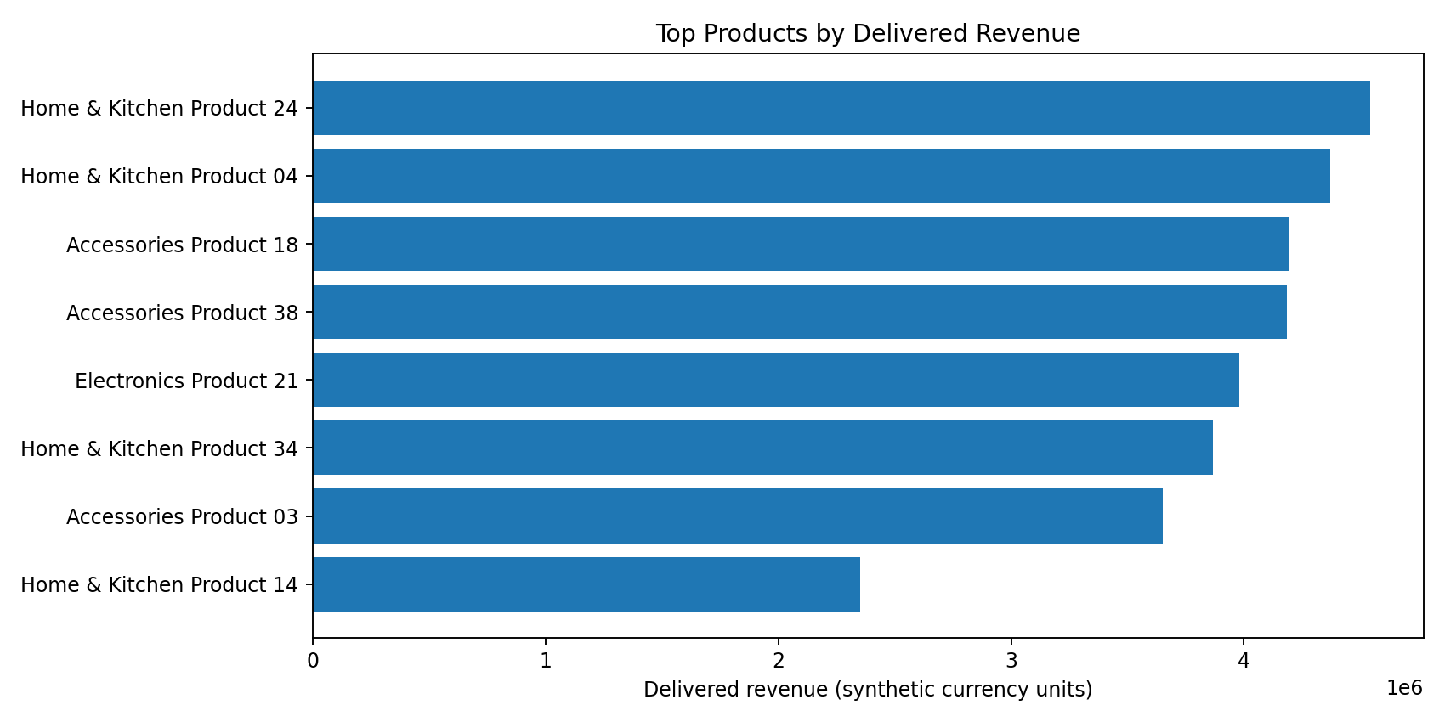
Figure 1. Top products by delivered revenue.
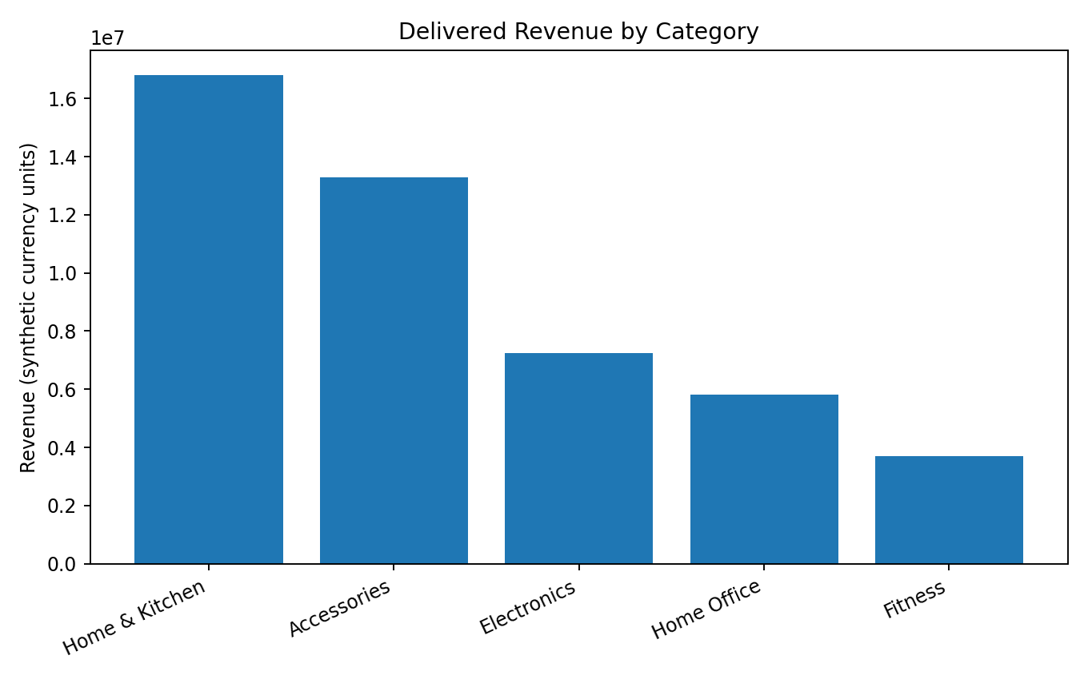
Figure 2. Category revenue comparison.
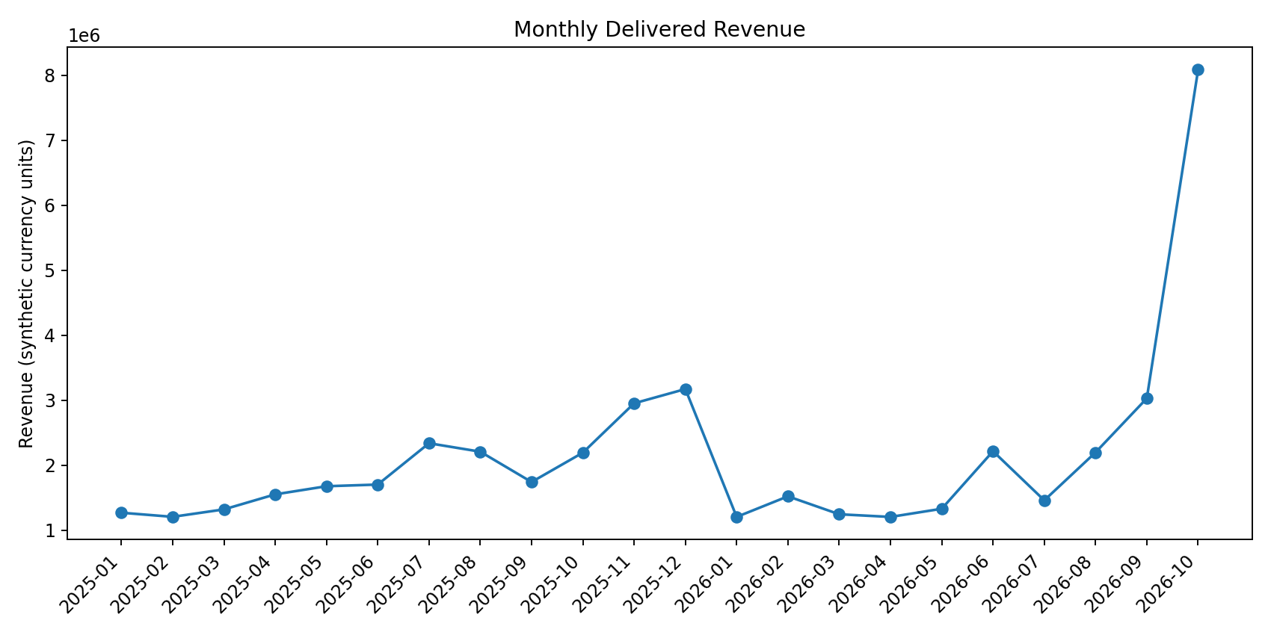
Figure 3. Monthly delivered revenue trend.
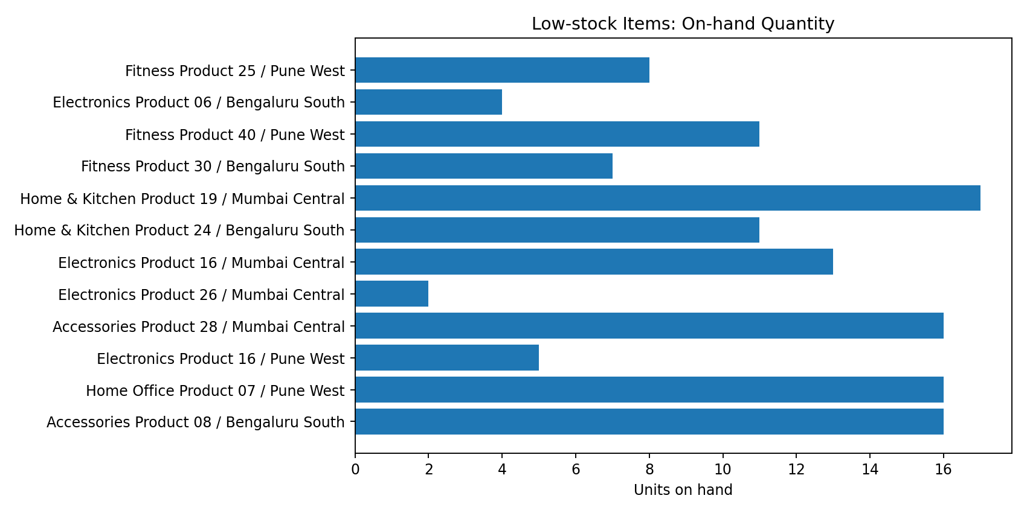
Figure 4. Low-stock quantities by product and warehouse.
Recommended dashboard layout: (1) KPI strip: delivered revenue, delivered orders, AOV, repeat-customer percentage and low-stock SKU/location count; (2) sales section: monthly trend, category mix and top products; (3) customer section: repeat purchase and top-customer Pareto; (4) inventory section: low-stock exceptions and stock-cover proxy; (5) operations section: order-status distribution and ageing. Every page should expose a date filter, status definition, refresh timestamp and drill-through to source rows.

8. Data Quality, Correctness and Validation
The synthetic generator is deterministic and the verification script runs all eight report queries automatically. It checks referential integrity for orders, order items and products; positive quantities; non-negative inventory; and non-negative delivered line values. Exact row counts and query outputs are saved under outputs/.
Validation check | Result
orders_have_customer | PASS
order_items_have_order | PASS
order_items_have_product | PASS
positive_quantities | PASS
nonnegative_inventory | PASS
delivered_sales_positive | PASS
Execution boundary: the local environment did not provide a PostgreSQL server/client. The queries were therefore executed against a SQLite mirror using equivalent query logic. The delivered SQL files are PostgreSQL-targeted; date formatting and timestamp literals are adapted in the PostgreSQL scripts. Before claiming PostgreSQL validation, run the scripts against the actual Week 1/3 PostgreSQL database and capture its version, row counts and EXPLAIN plans.

9. Risks, Limitations and Future Improvements
- Add a returns/refunds table and discount/tax fields so gross merchandise value, refunds, net sales and recognized revenue can be reported separately.
- Add inventory_movements with movement type, timestamp, quantity delta, warehouse and unit cost. This enables true inventory turnover, days inventory outstanding and stock reconciliation.
- Add warehouse_id to order fulfilment/shipments or order items to attribute demand to the correct warehouse.
- Build customer cohorts by acquisition month and calculate repeat purchase at fixed horizons; do not treat the simple repeat rate as retention.
- Add promotion calendar, traffic/session and campaign attribution to explain sales changes rather than infer causality from a line chart.
- Add currency_code and exchange-rate policy before combining international sales.
- Create governed reporting views/materialized views with refresh timestamps, role-based access and data lineage.
- Benchmark dashboard queries under realistic concurrency; capture PostgreSQL EXPLAIN (ANALYZE, BUFFERS), median latency and index sizes.
Optimization trade-off principle: an optimization is accepted only when it preserves the report definition and result, improves a measured workload characteristic, and has an acceptable maintenance cost. Indexes can speed reads but slow writes and consume disk. Materialized views reduce repeated computation but introduce staleness and refresh load. Partitioning can prune large time ranges but adds operational complexity and is not justified for a small dataset.

10. Conclusion
Week 4 turns the inherited retail data model into a practical reporting specification. Eight business questions are answered using joins, aggregations, CTEs, conditional expressions, subqueries and window functions. The package includes deterministic synthetic data, executed query outputs, CSV exports, chart examples, validation checks and PostgreSQL SQL scripts. The most important analytical discipline is to define each metric before charting it: delivered merchandise revenue is not net revenue, a reorder threshold is not a forecast, and stock cover is not inventory turnover. Future work should add returns, stock movements, warehouse-level demand attribution and cohort analysis, then validate the PostgreSQL execution plans and benchmark dashboard workloads.

Appendix A. Run Instructions
1. Create a disposable PostgreSQL database. 2. Load the Week 1 schema and any required data, or use the supplied synthetic generator for the isolated test dataset. 3. Review SQL scripts and confirm schema/table names. 4. Run each file in sql/ against PostgreSQL 15+. 5. Capture EXPLAIN (ANALYZE, BUFFERS, VERBOSE) for selected expensive queries. 6. Compare the PostgreSQL outputs with the included SQLite verification outputs only after aligning dataset, timestamps and business definitions.

Appendix B. Included Files
- sql/: eight PostgreSQL reporting queries.
- scripts/generate_and_verify.py: deterministic dataset generator and query verification runner.
- data/: generated CSV data extracts and SQLite verification database.
- outputs/: exact CSV and Markdown result tables, row counts and validation summary.
- visualizations/: four chart examples used in the report.
- docs/: submission description and metric dictionary.

